**Congratulations! You passed!**

**Grade received** 100%

**To pass** 70% or higher

Go to next item

**1.**

Question 1

Use the following diagram and value of parameters to answer all the series of questions:

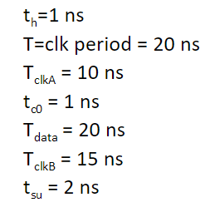

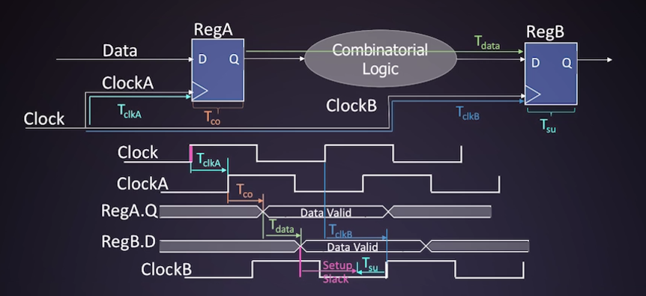

**What is the *Setup* Required Time in ns?**

**1 / 1 point**



33 ns



35 ns



15 ns



13 ns

**Correct**

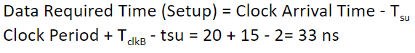

**2.**

Question 2

**What is the *Setup* Arrival Time in ns?**

**1 / 1 point**



30 ns



31 ns



10 ns



11 ns

**Correct**

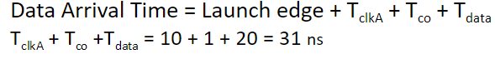

**3.**

Question 3

**What is the *Setup* slack time in ns?**

**1 / 1 point**



-5 ns



+2 ns



+5 ns



-2 ns

**Correct**

**Required Time - Arrival Time = 2 ns**